Interoperability, from the official website and blogs related to the official website and case studies found on Youtube and other case studies:

<https://incepto-medical.com/en/solutions/qxr>

<https://www.qure.ai/how-we-deploy/>

<https://qure.ai/product/qxr/>

<https://qure.ai/blog/>

<https://www.qure.ai/re-purposing-qxr-for-covid-19/>

<https://qure.ai/scaling-up-tb-screening-with-ai-deploying-automated-x-ray-screening-in-remote-regions/>

Distinguish normal and abnormal chest X-rays. Classify them into three categories, normal, abnormal, undetermined. For the undetermined results, a human expert might need to be involved for further diagnosis. For the abnormal ones, qXR can help diagnose approximately 24 diseases. A report will be generated for further examination. The deployment of qXR along with other products of the qure.ai company are all based on two integration models, API and PACS (Cailin mentioned). Those features are mentioned in the integration into workflow section but it is still important when it comes to exporting data. Also, another important use of technology is cloud service, the client has the opinion of uploading to the appointed cloud and storing the scans and reports into a private cloud. Downloading the scans and reports to local hard drives is also an opinion. For further research and other purposes, the researchers can simply pull out the report generated by qXR and conduct the research. For example, if the research is about the correlation of smoking and lung cancer, the researcher can pull out the reports of a bunch of patients who did chest scans and allow the research to be conducted, the researcher will then compare a matched group study to find out if smoking causes lung cancer. qXR results will be the factor determining if the patient is diagnosed with lung cancer or not. Quite a simple and normal research example.

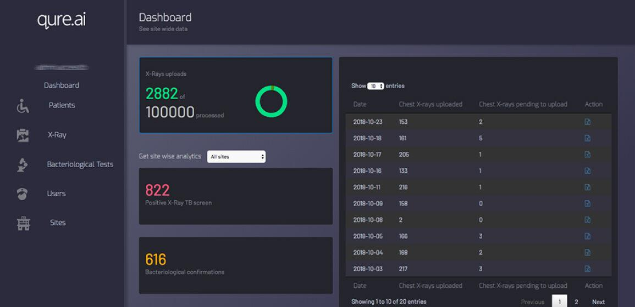

This is the patient management dashboard for all the products qXR company is using.

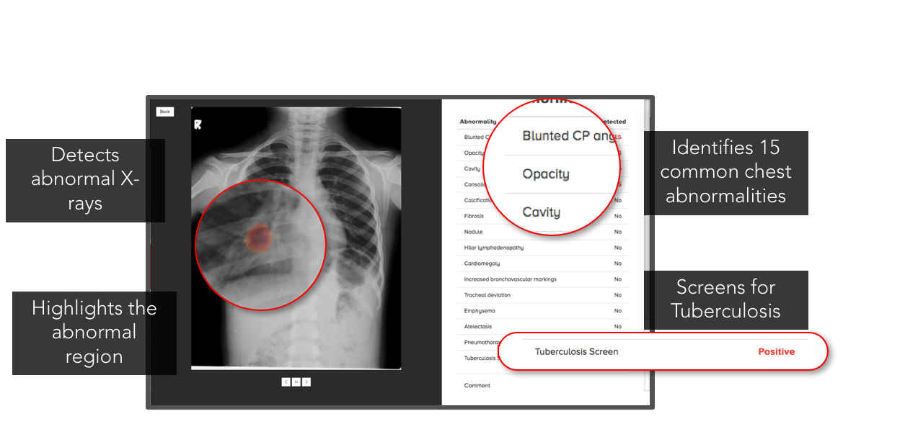

This is a sample qXR generated result. All the features above can be used for further research. The main purpose is to list out the abnormal part of the patient’s scan, point out the location of such abnormality and the type of abnormality, such as opacity, cavity, nodule…

This is another sample output.

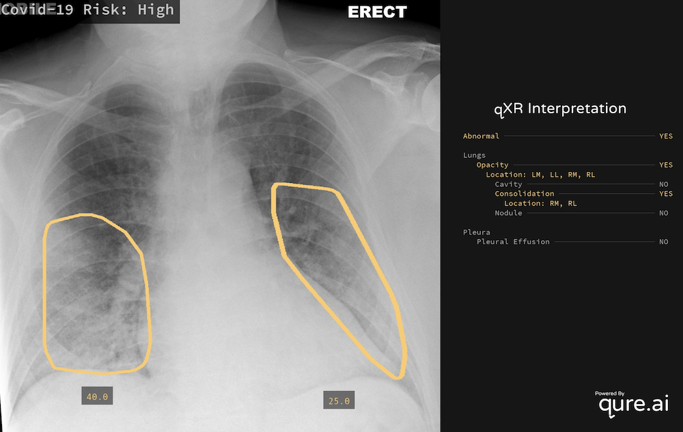

Such results are solidly based on radiology and medical practice, should be easy to read and further analyzed by people with medical expertise. Assuming qXR can produce results with high accuracy, such results can be widely accepted by the medical imaging community.

This report does not aim to reach for the interoperability for the actual model of the AI because this product is less related with AI and more related with medical imaging. And also, the algorithms and models qure.ai implemented in qXR is probably confidential, as an intellectual property being protected. I don’t see discussion of their algorithms. Anyway, it is designed for medical imaging and imaging processing specifically, combination of algorithm design, high level of understanding of all the radiology, and diagnostic practice.